**Big Data and Predictive Analysis**

Assignment 1

**Lab Part-1**

**Market Basket Analysis/Association Analysis**

Submitted by

#### Case Study 1: Conducting an Association Analysis

A store is interested in determining the associations between items purchased from the Health and Beauty Aids Department and the Stationery Department. The store chose to conduct a market basket analysis of specific items purchased from these two departments. The **TRANSACTIONS** data set contains information about more than 400,000 transactions made over the past three months. The following products are represented in the data set:

1. bar soap
2. bows
3. candy bars
4. deodorant
5. greeting cards
6. magazines
7. markers
8. pain relievers
9. pencils
10. pens
11. perfume
12. photo processing
13. prescription medications
14. shampoo
15. toothbrushes
16. toothpaste
17. wrapping paper

There are four variables in the data set:

|  |  |  |  |
| --- | --- | --- | --- |
| **Name** | **Model Role** | **Measurement Level** | **Description** |
| **STORE** | Rejected | Nominal | Identification number of the store |
| **TRANSACTION** | ID | Nominal | Transaction identification number |
| **PRODUCT** | Target | Nominal | Product purchased |
| **QUANTITY** | Rejected | Interval | Quantity of this product purchased |

* 1. Create a new diagram. Name the diagram **Transactions**.
  2. Create a new data source using the data set **AAEM.TRANSACTIONS**.
  3. Assign the variables **STORE** and **QUANTITY** the model role Rejected. These variables will not be used in this analysis. Assign the ID model role to the variable **TRANSACTION** and the Target model role to the variable **PRODUCT**.
  4. Add the node for the **TRANSACTIONS** data set and an Association node to the diagram.
  5. Change the setting for Export Rule by ID to **Yes**.
  6. Leave the remaining default settings for the Association node and run the analysis.

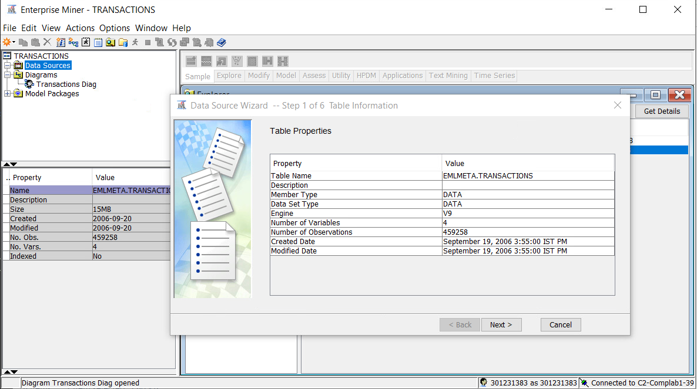

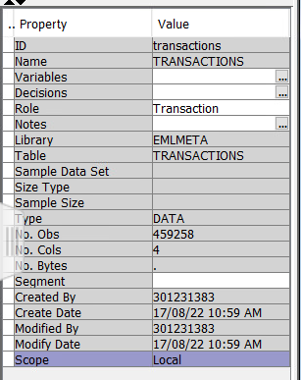

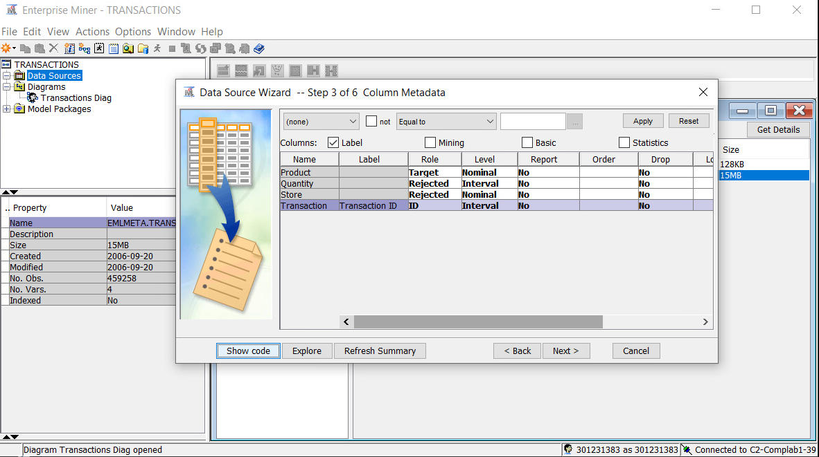

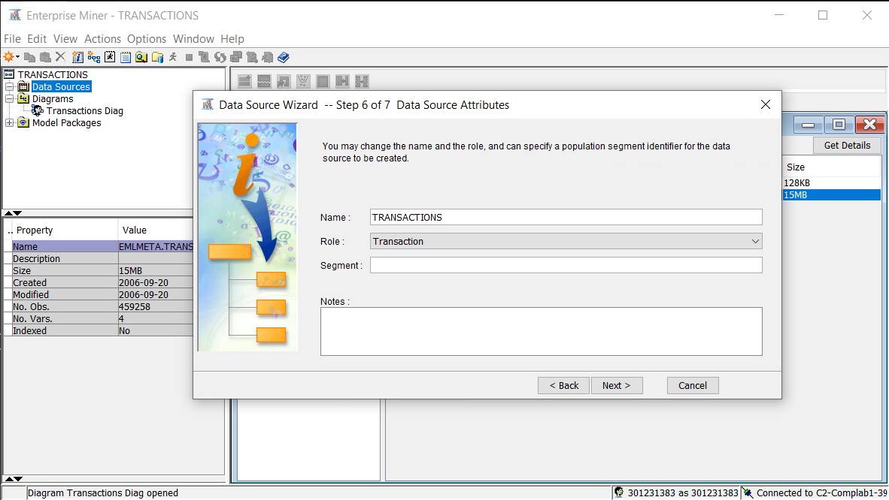

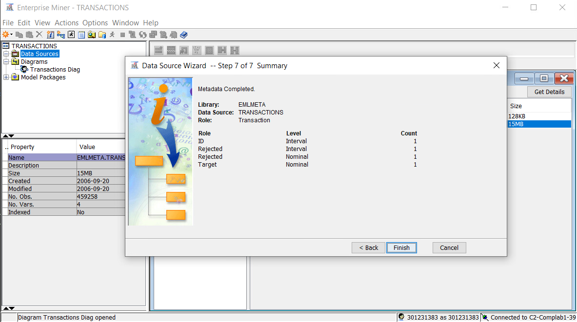

Change the setting for Export Rule by **ID to Yes.**

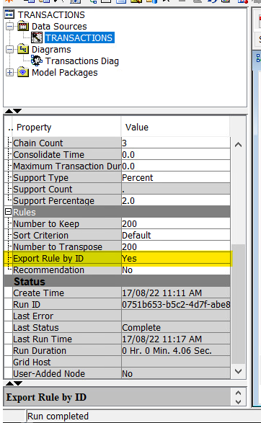

**Answers: Show your Association diagram here:**

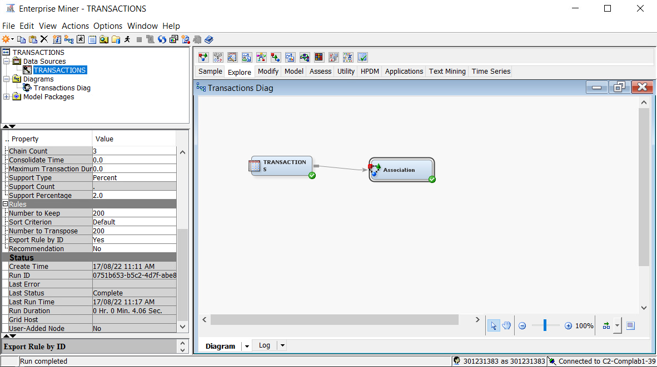

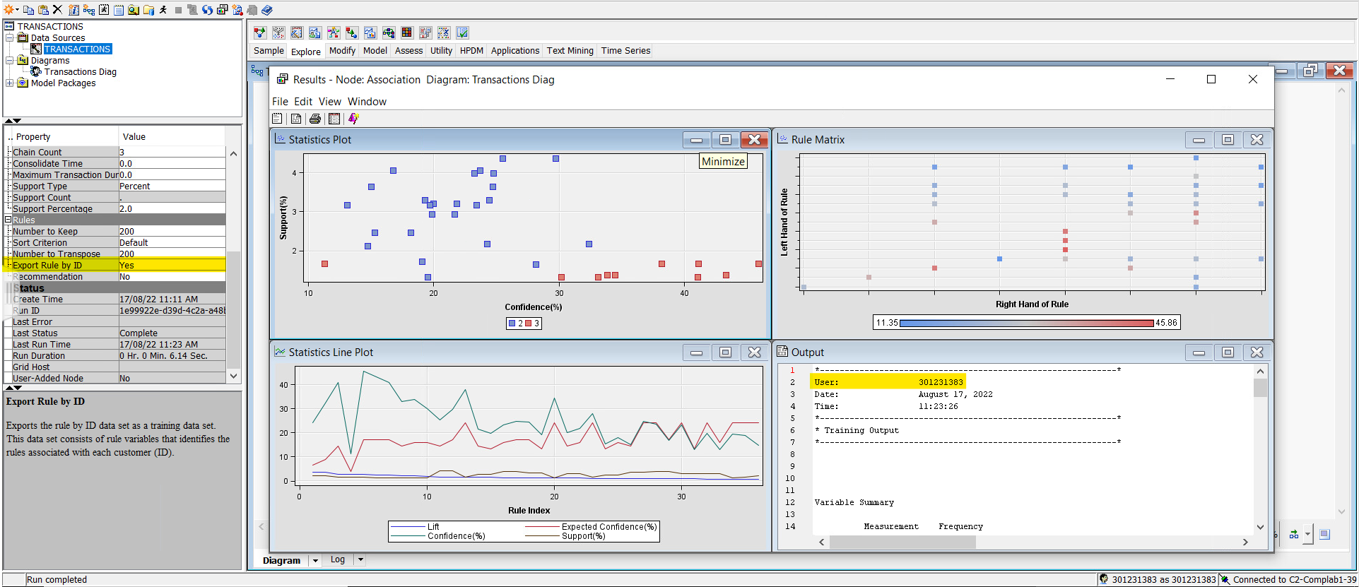

* 1. Examine the results of the association analysis.

**Output of Association Report:**

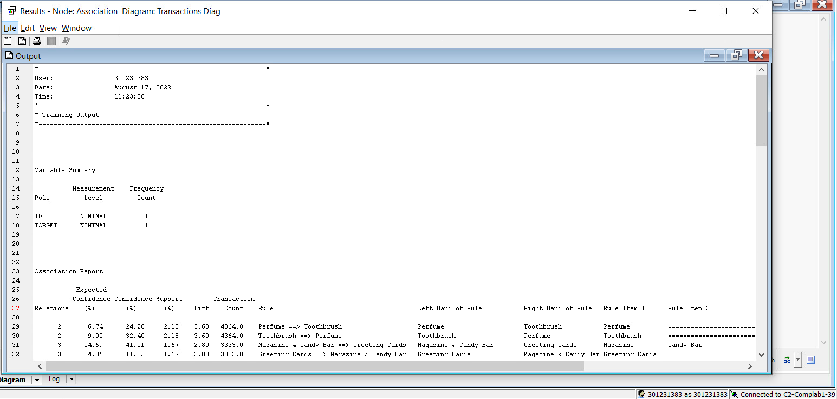

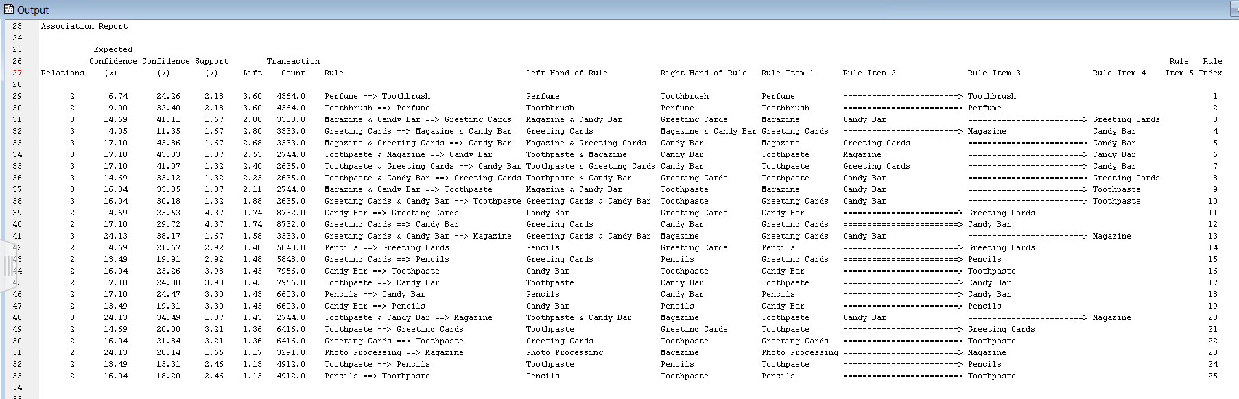

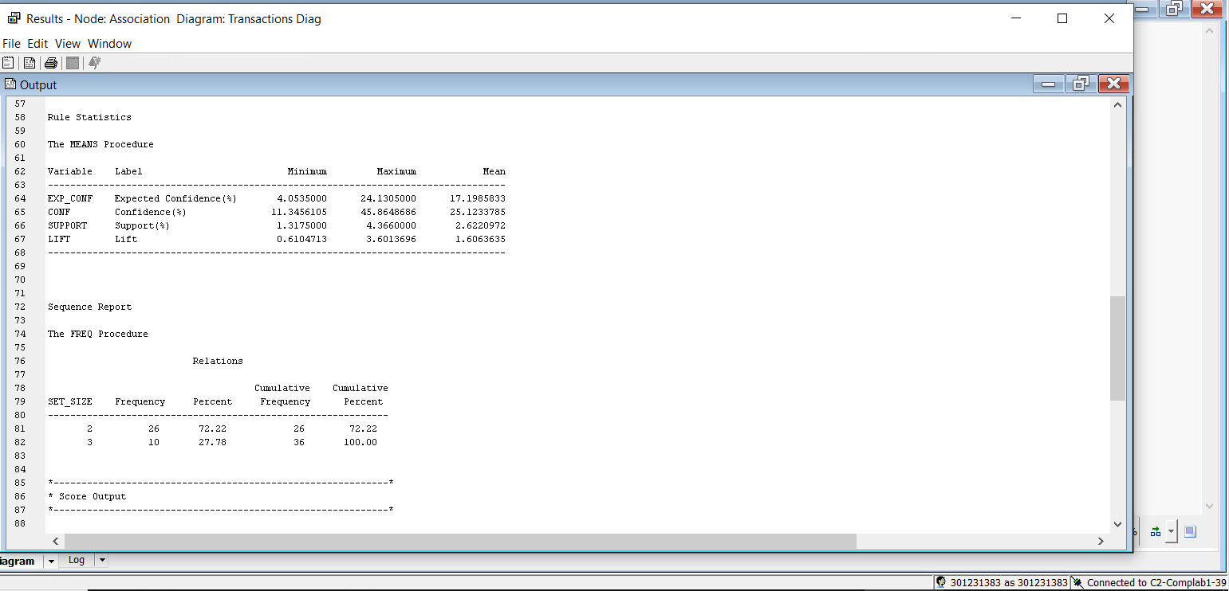

The highest lift value for the resulting rules is 3.60.

What is the highest lift value for the resulting rules?

Based on the result, rule has this value i.e., Perfume 🡺 Toothbrush

Which rule has this value?

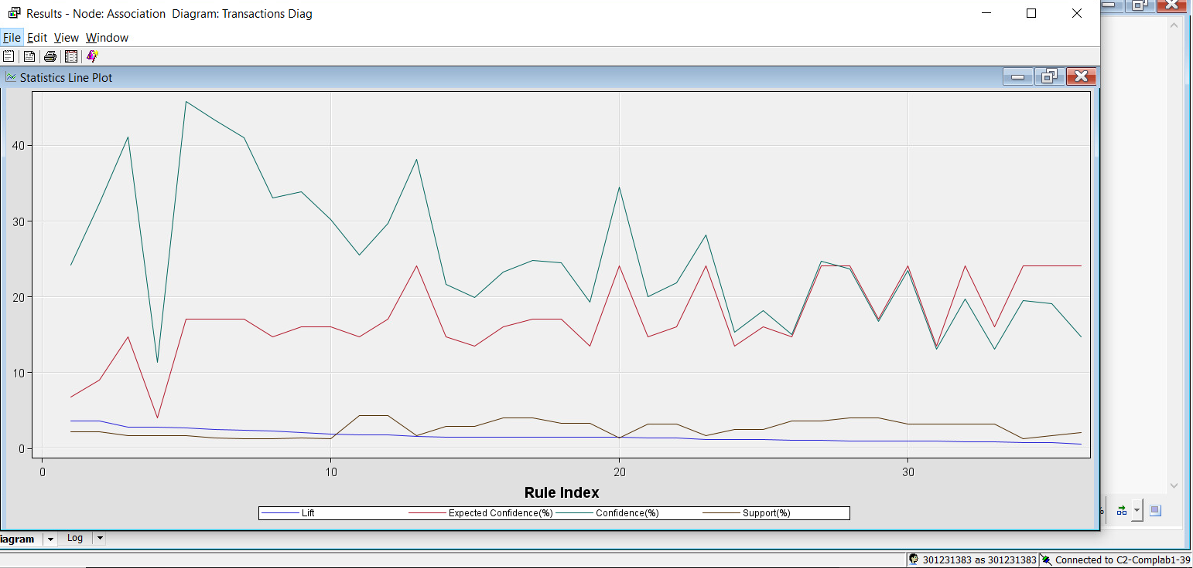

Hence, the Rule 1 has the highest lift value, 3.60. Looking at the output reveals that Rule 1 is the rule Toothbrush ==> Perfume.

This rule can be applied in three distinct ways by a store manager to boost sales of connected goods.

1) The retail can locate these items in the identical sections.

2) The sales manager may discount the price on either of the two items and combine their sale.

3) The sales manager can promote either of the two goods and combine sales of both.

**Summary:**

Through this activity, I was able to comprehend the market tactics that can be used in accordance with lift values to boost sales for products that can be marketed in combination. To determine if the store manager could take any action for the products, such as grouping like items for sale or placing them close together to boost sales, we looked at various rules and their Lift, Support, Confidence, and Expected Confidence values.

#### Case Study 2: Conducting a Sequence Analysis

A radio station developed a Web site to broaden its audience appeal and its offerings. In addition to a simulcast of the station’s primary broadcast, the Web site was designed to provide services to Web users, such as podcasts, news streams, music streams, archives, and live Web music performances. The station tracked usage of these services by URL. Analysts at the station wanted to see whether any unusual patterns existed in the combinations of services selected by its Web users.

The **WEBSTATION** data set contains services selected by more than 1.5 million unique Web users over a two-month period in 2006. For privacy reasons, the URLs are assigned anonymous ID numbers.

#### Case Study Data

|  |  |  |  |
| --- | --- | --- | --- |
| **Name** | **Model Role** | **Measurement Level** | **Description** |
| **ID** | ID | Nominal | URL (with anonymous ID numbers) |
| **TARGET** | Target | Nominal | Web service selected |

**🖉** The **WEBSTATION** data set should be assigned the role of **Transaction**. This role can be assigned either in the process of creating the data source or by changing the properties of the data source inside SAS Enterprise Miner.

#### Accessing and Assaying the Data

A SAS Enterprise Miner data source was defined for the **WEBSTATION** data set using the metadata settings indicated above. By right-clicking on the Data Source node in the diagram and selecting **Edit Variables**, the **TARGET** variable can be explored by highlighting the variable and then selecting **Explore**. (The following results are obtained by specifying **Random** and **Max** for the Sample Method and Fetch Size.)

The Sample Statistics window shows that there are over 128 unique URLs in the data set and 8 distinct services.

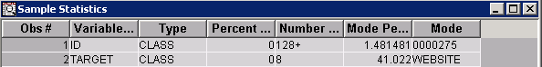

A plot of target distribution (produced from the Explore window) identified the eight levels and displayed the relative frequency in a random sample of 100000 cases.

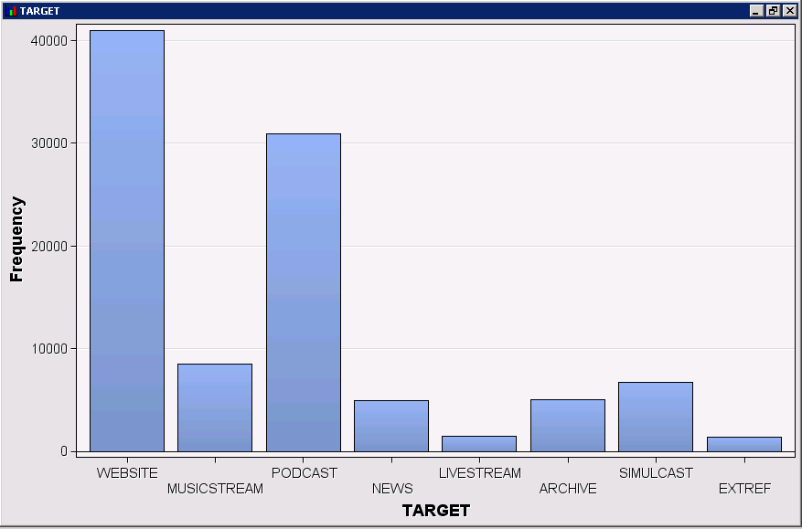

#### Generating Associations

An Association node was connected to the **WEBSTATION** node.

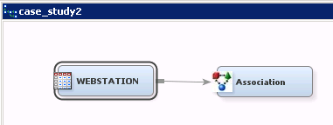

A preliminary run of the Association node yielded very few association rules. It was discovered that the default minimum Support Percentage setting was too large. (Many of the URLs selected only one service, diminishing the support of all association rules.) To obtain more association rules, the minimum Support Percentage setting was changed to **1.0**. In addition, the number of items to process was increased to **3000000** to account for the large training data set.

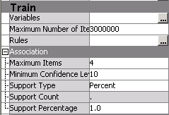

Using these changes, the analysis was rerun and yielded substantially more association rules. The Rules Table was used to scrutinize the results.

The following were among the interesting findings from this analysis:

1. Where do most external referrers to the Web site point to? (i.e. what is the strongest association for external referrers?) and what is the confidence level?

The highest lift value for the resulting rules is 13.42. Thus, the strongest association for Website & External Referrer (EXTREF) is to the Archive (ARC) i.e., WEB & EXTREF ==> ARC. Hence, most external referrers to the website pointed to the programming archive.

Based on the result, the Confidence percentage is 98.07 or 98% confidence.

1. If someone selects the simulcast service, what are the chances that they also select the news service.

If someone selects the simulcast service, then “tripled” the chances that they also select the news swevice. Approimately, there is a 22% chances of news service.

1. Identify at least three other unusual or significant patterns in the combinations of the services chosen by the Web users of the radio station.

Users who used streamed Music were less likely to go to the website or web users of the radio station.

Users who used download podcasts were less likely to go to the web users of the radio station.

Users who used the news service or listned to the simulcast were less likely to go to the web users of the radio station.